SILVER OAK UNIVERSITY

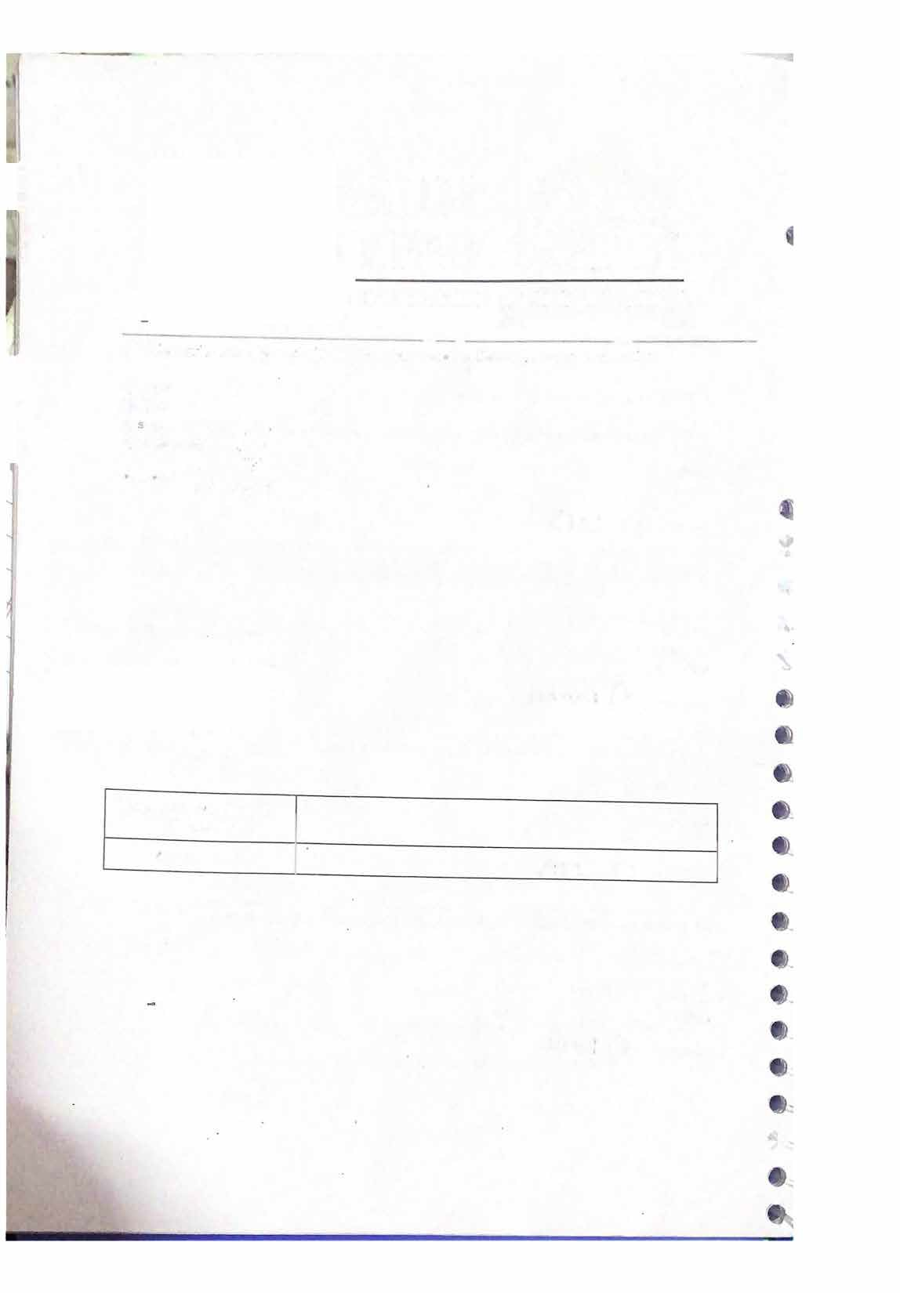

**EDUCATION TO INNOVATION**

5. Whirh nt111hu1e can be used with the <ol> tag to�han;e the numbering style ofth<01 s1?

u) !'>t.irt

d) '1umbe r Jnq

Answer: b) � e__

**I 1**

Signature\\ ith Date of Completion

Marks out of 1 O